Activity 3
Samantha Krall
CST-236

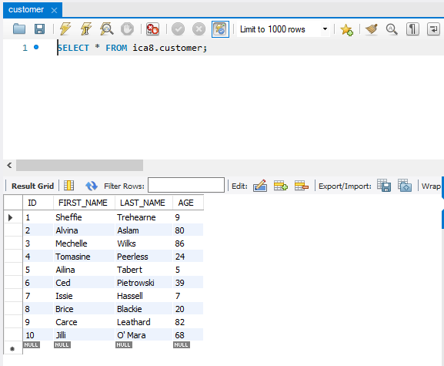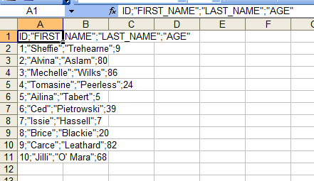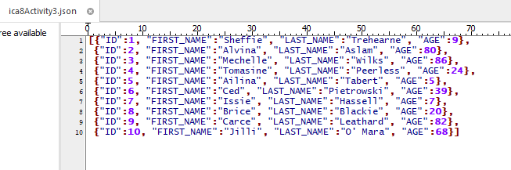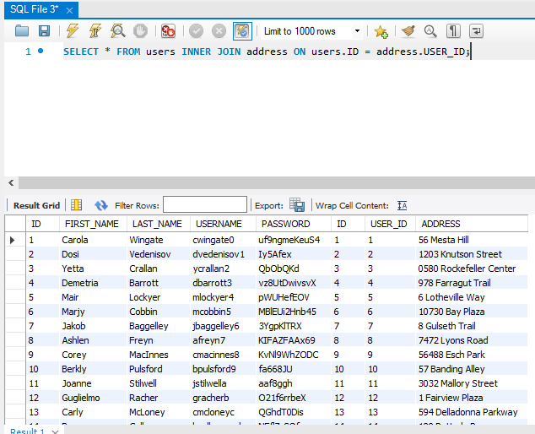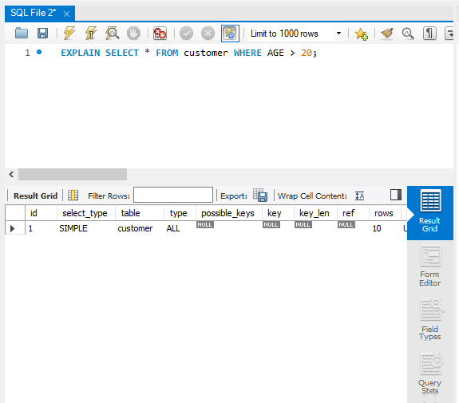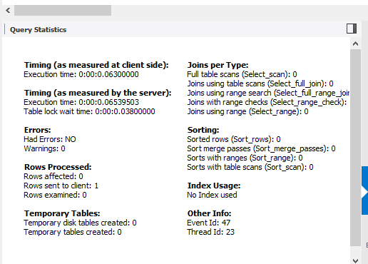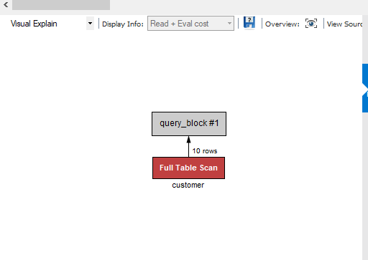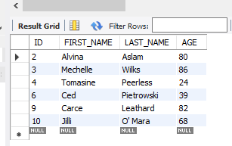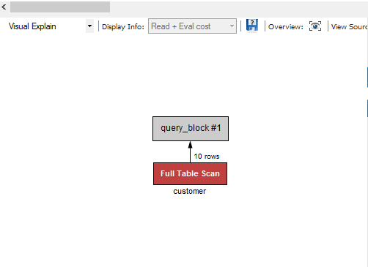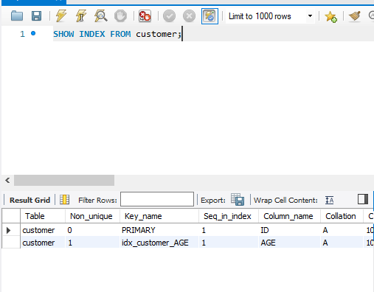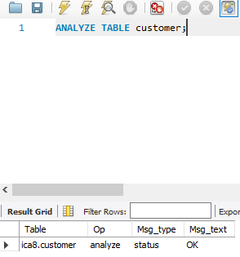
The explain plan statement displays execution plans for select, update, insert and delete statements. The row source tree is the core of the execution plan. It shows an ordering of the tables referenced by the statement, an access method for each table mentioned in the statement, a join method for tables affected by join operations in the statement and data operations like filter, sort or aggregation. In addition, the plan table contains information about optimization, such as the cost and cardinality of each operation, partitioning, such as the set of accessed partitions, and parallel execution, such as the distribution method of join inputs.

References:
https://docs.oracle.com/cd/B28359_01/server.111/b28274/ex_plan.htm#CHDCGHDG

